BRD
Business Requirements Document (BRD)
Project: Pizza Sales Analysis
Project Overview
The Pizza Sales Analysis project is designed to analyse transactional sales data from a pizza store. The goal is to identify key business insights, trends, and KPIs that will help management make informed decisions related to sales, marketing, and operations.

Business Objectives
- Identify overall revenue, total pizzas sold, and total number of orders.
- Determine sales distribution by pizza category, size, and type.
- Analyse time-based trends in sales (daily, monthly, and yearly).
- Highlight best-selling and least-selling pizzas by revenue and quantity.
- Understand customer purchasing behaviour through Average Order Value (AOV) and Average Pizza per Order.
- Provide visualization dashboards for effective decision-making.

Data Source & Description
Dataset: pizza_sales.csv
Key fields:
- order_id → Unique identifier for each order
- pizza_id → Unique identifier for each pizza
- pizza_name → Name of the pizza sold
- quantity → Number of pizzas sold per order
- total_price → Total revenue for each transaction
- date, time → Order timestamp for time-based analysis
- pizza_category, pizza_size → Attributes for pizza classification

Key Performance Indicators (KPIs)
- Total Revenue = Sum of total_price
- Total Pizzas Sold = Sum of quantity
- Total Orders = Count of unique order_id
- Average Order Value (AOV) = Total Revenue ÷ Total Orders
- Average Pizza per Order = Total Pizzas Sold ÷ Total Orders

Analysis & Visualizations
Ingredient Analysis
The pizza business aims to understand which ingredients are most frequently used across different pizza types. By identifying the most common ingredients, the store can

Daily Trend
A line/bar chart showing sales by day of the week.
- Useful for staffing and operations planning.

Hourly Trend
A line/bar chart showing sales by hour of the day.
Useful for staffing, ingredients, customer rush and operations planning

Monthly Trend
A line chart depicting monthly revenue and orders.
- Helps track seasonality and identify peak sales months.
- Summer months show higher sales due to promotional campaigns.

% of Sales by Category
A bar chart representing revenue and quantity sold for each pizza category (Classic, Supreme, Veggie, Chicken).
- Helps identify customer preferences.
- Classic pizzas dominate sales, while Veggie has lower demand.

% Sales by Pizza Size & Category
A bar/ donut chart comparing sales revenue and quantity by pizza size (S, M, L, XL).
- Highlights demand distribution by size and assist inventory planning.
- Large (L) pizzas contribute the highest revenue.

Total Pizzas Sold by Pizza Category
- Manage inventory by stocking ingredients used in the most popular categories.
- Evaluate if low-performing categories should be optimized, redesigned, or discontinued.

Top 5 Best-Selling Pizzas
A horizontal bar chart showing pizzas with the highest sales (by revenue, orders or quantity).
- Supports promotional and menu strategy.

Bottom 5 Least-Selling Pizzas
A horizontal bar chart of pizzas with the lowest sales.
- Identifies products for improvement or possible removal from the menu.

Business Questions Answered
- What is the total revenue generated?
- How many pizzas were sold in total?
- Which category and size of pizzas perform best?
- Which pizzas are the top and bottom performers?
- What is the average order value and average pizzas per order?
- What are the sales trends by day, month, and time of day?

Deliverables
- Jupyter Notebook with complete Python analysis.
- Visualizations (bar charts, line charts, trend charts).
- Business Requirements Document (BRD).
- Insights and recommendations for management.

Conclusion & Recommendations
The analysis provides a comprehensive view of pizza sales performance. Management can leverage these insights to:
- Focus marketing on high-performing categories.
- Optimize the menu by reconsidering least-selling pizzas.
- Plan inventory and staffing based on sales peaks.
- Monitor KPIs regularly through dashboards for continuous improvement.

SQL Queries
Sales SQL Queries

A. KPI’s (Key Performance Indicators)
- Total_Revenue:
select sum(total_price) as Total_Revenue from pizza_sales_excel_file;
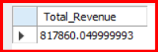
- Average_order_value
select sum(total_price)/count(distinct order_id) as Avg_order_value from pizza_sales_excel_file;
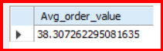
- Tota_Pizza_sold
select sum(quantity) as Total_pizza_sold from pizza_sales_excel_file;
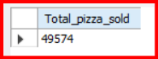
- Total_Orders
select count(distinct order_id) as Total_orders from pizza_sales_excel_file;
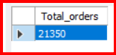
- Avg_pizzas_per_order
select cast(cast(sum(quantity) as decimal(10,2))/
cast(count(distinct order_id) as decimal(10,2)) as decimal(10,2)) as Avg_Pizzas_per_order from pizza_sales_excel_file;
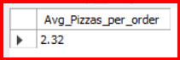
B. Analysis & Visualisation

- Daily Trend
SELECT DAYNAME(STR_TO_DATE(order_date, '%d-%m-%Y')) AS order_day,
COUNT(DISTINCT order_id) AS Total_orders
FROM pizza_sales_excel_file
GROUP BY order_day
ORDER BY FIELD(order_day, 'Sunday', 'Monday', 'Tuesday', 'Wednesday', 'Thursday', 'Friday', 'Saturday');
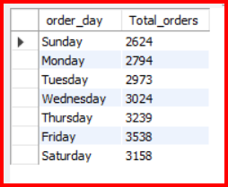

- Monthly_Trend
SELECT MONTHNAME(STR_TO_DATE(order_date, '%d-%m-%Y')) AS Month_Name,
COUNT(DISTINCT order_id) AS Total_orders
FROM pizza_sales_excel_file
GROUP BY Month_Name
ORDER BY FIELD(Month_Name, 'January', 'February', 'March', 'April', 'May', 'June', 'July', 'August', 'September', 'October', 'November', 'December');
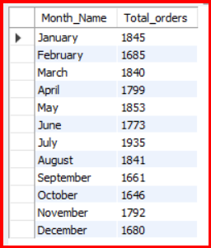
- PCT_of_sales_by_pizza_category
SELECT
pizza_category,
SUM(total_price) AS Total_sales,
CONCAT(
ROUND(
SUM(total_price) * 100 / (
SELECT SUM(total_price)
FROM pizza_sales_excel_file
WHERE MONTH(STR_TO_DATE(order_date, '%d-%m-%Y')) = 1
), 2
), '%'
) AS PCT
FROM pizza_sales_excel_file
WHERE MONTH(STR_TO_DATE(order_date, '%d-%m-%Y')) = 1
GROUP BY pizza_category;
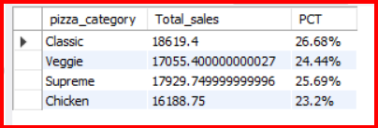
- Top 5 Pizza_by_Revenue_in_DESC
select pizza_name, sum(total_price) as Total_Revenue from pizza_sales_excel_file
group by Pizza_name
order by Total_Revenue desc
limit 5;
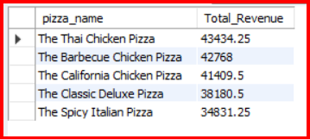
- Top 5 Pizza_by_Revenue_in_ASC
select pizza_name, sum(total_price) as Total_Revenue from pizza_sales_excel_file
group by Pizza_name
order by Total_Revenue asc
limit 5;
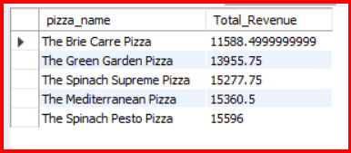
- Top 5 Best_selling_Pizza
select pizza_name, sum(quantity) as Total_Quantity from pizza_sales_excel_file
group by Pizza_name
order by Total_Quantity desc
limit 5;
